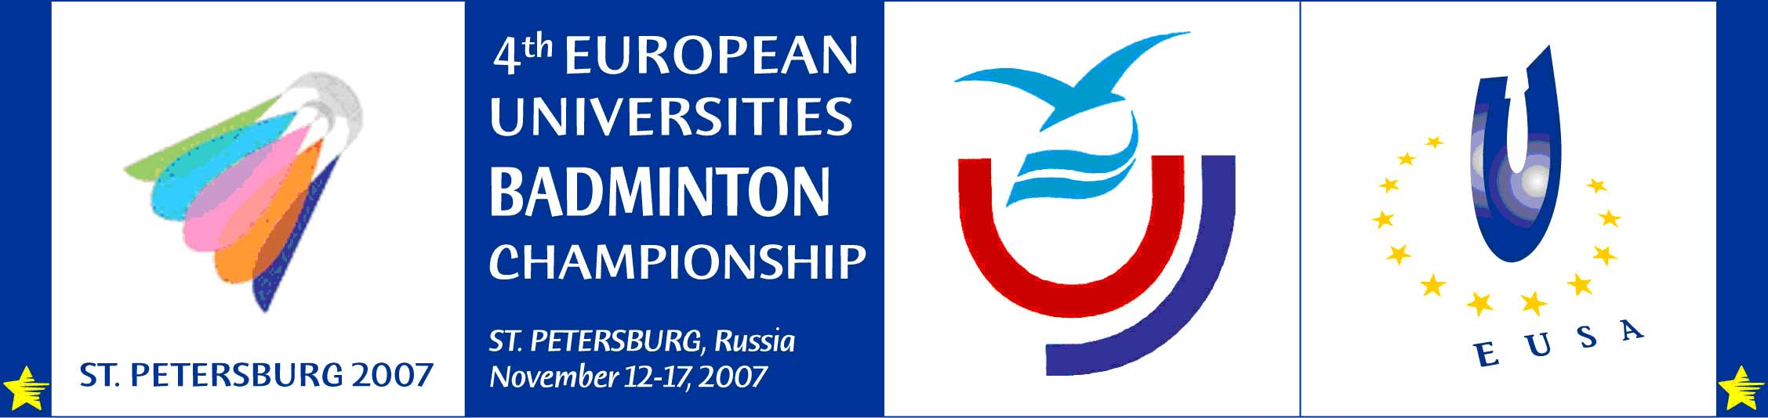

INDIVIDUAL ENTRY FORM

^{4th} European University Badminton Championship
St.Petersburg, November 12th to November 17th , 2007

Address of the Organising Committee:
Marsovo Pole 5, St.Petersburg, Russia
tel.: +7 812 3254468, fax: +7 812 3254468, website: www.eusa.spb.ru,
e-mail: badm2007spb@mail.ru
Contact persons: Fedorova Alexandra, Rozhdestvenskaya Valeria

Photo

Country: …………………………………………………

University: ……………………………………………....

Family Name:……..……………………………………..

First name: ………..…………………………………….

Sex (m/w): ……………..…………………………………

Date of birth: ………………………..…………………..

Faculty: .……………………………………..……………

Field of study:……..……………………………..……………………………………

Year of study: ……….……………………………..…………………………………

Graduation date:………………………………………...……………………………

Passport (ID card) nr.: ………………………..……………………………………..

Address: ………………..……………………………………………………………..

City: …………..……………………………………………………………………….

General remarks (vegetarian, …): ………………………………………………..…

Signed by:

Seal

Name: …………………………………………………….

Position: …………………………………………………..

Date: ………………………………………………………

Signature: …………………………………………………

EUSA approval: ……………………………………………………………………………….

Deadline: Oct 12th , 2007 Entry to be sent to the Organising Committee

